Calculating Family Expenses using Service Now

# Creation of New Update Set

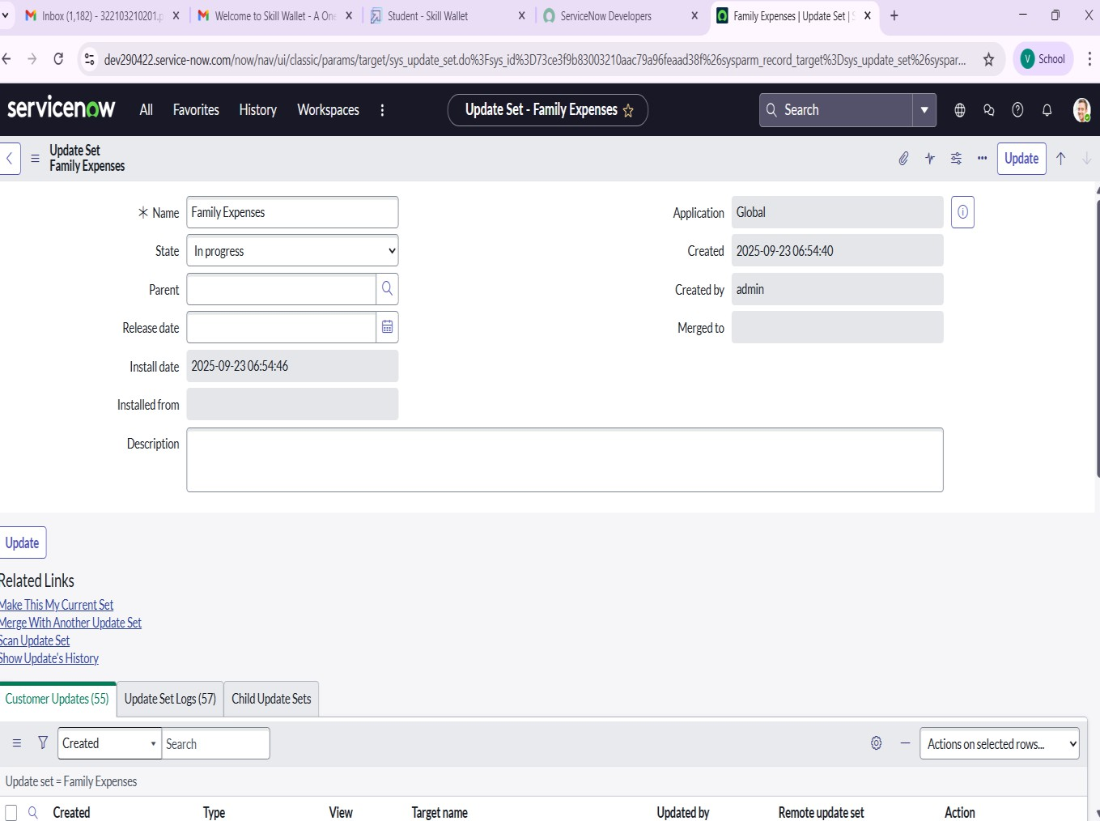

# Creation of Family Expenses Table

# Creation of Columns(Fields)

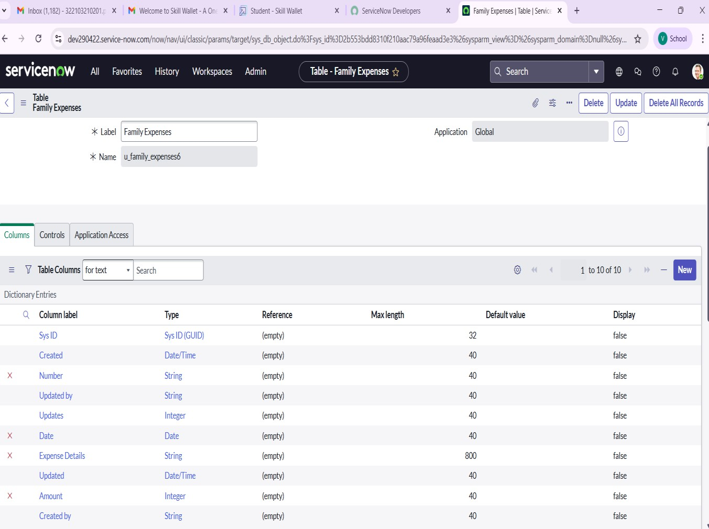

# Making Number Field an Auto-Number

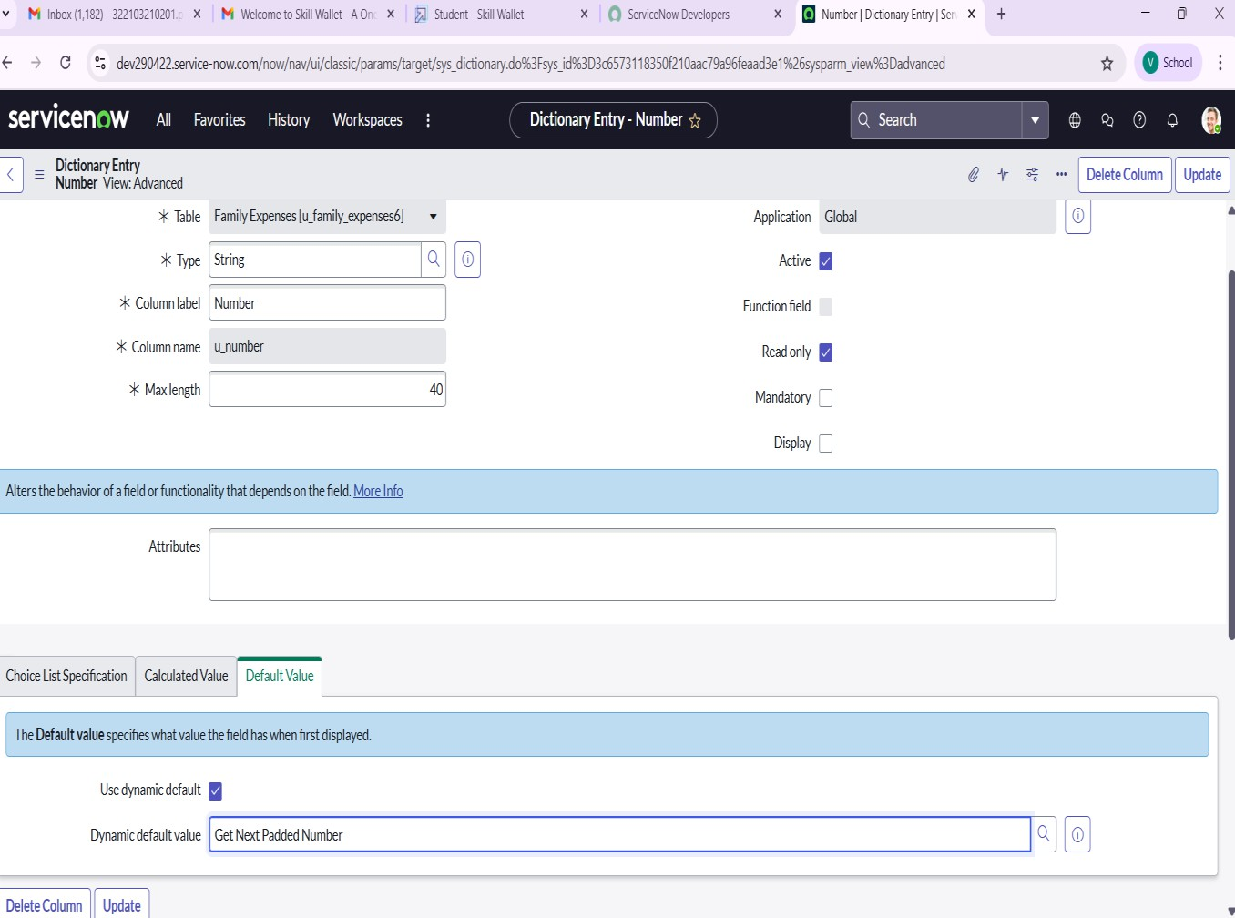

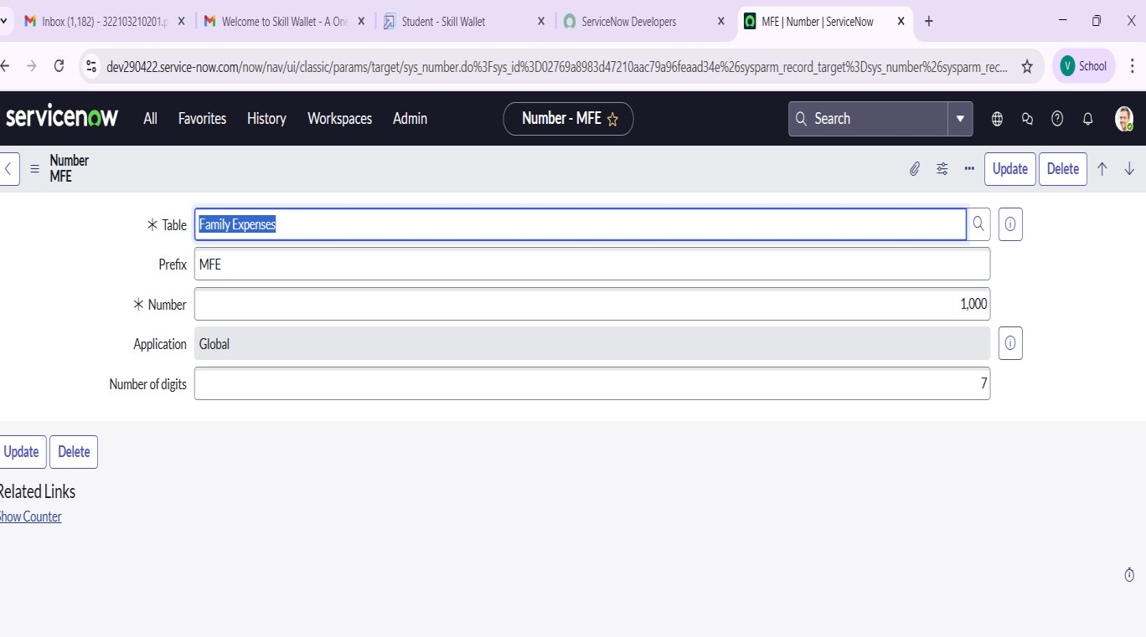

**Configure the Form**

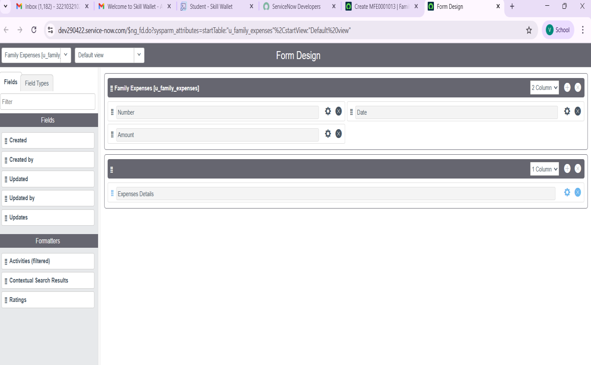

# Creation of Daily Expenses Table

# Creation of Columns(Fields)

# 

# Making Number Field an Auto-Number

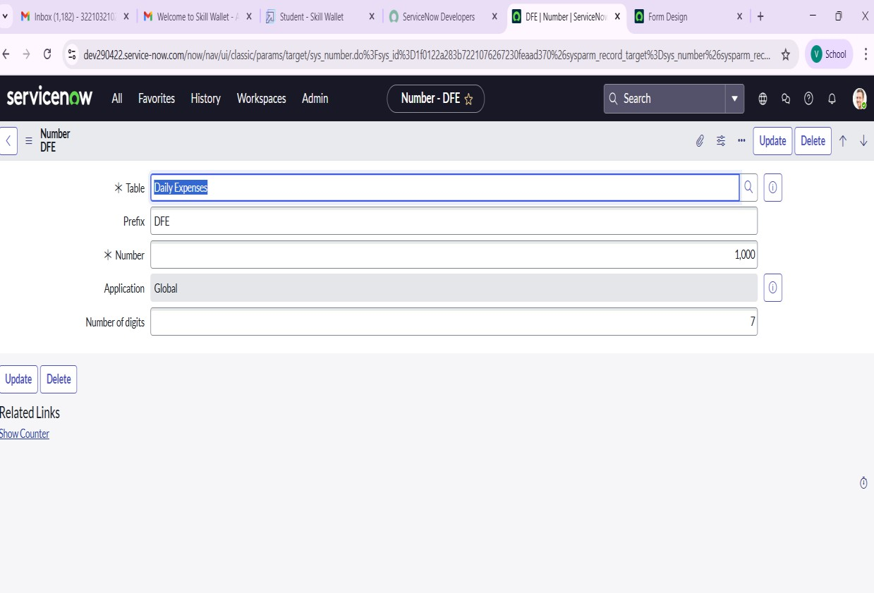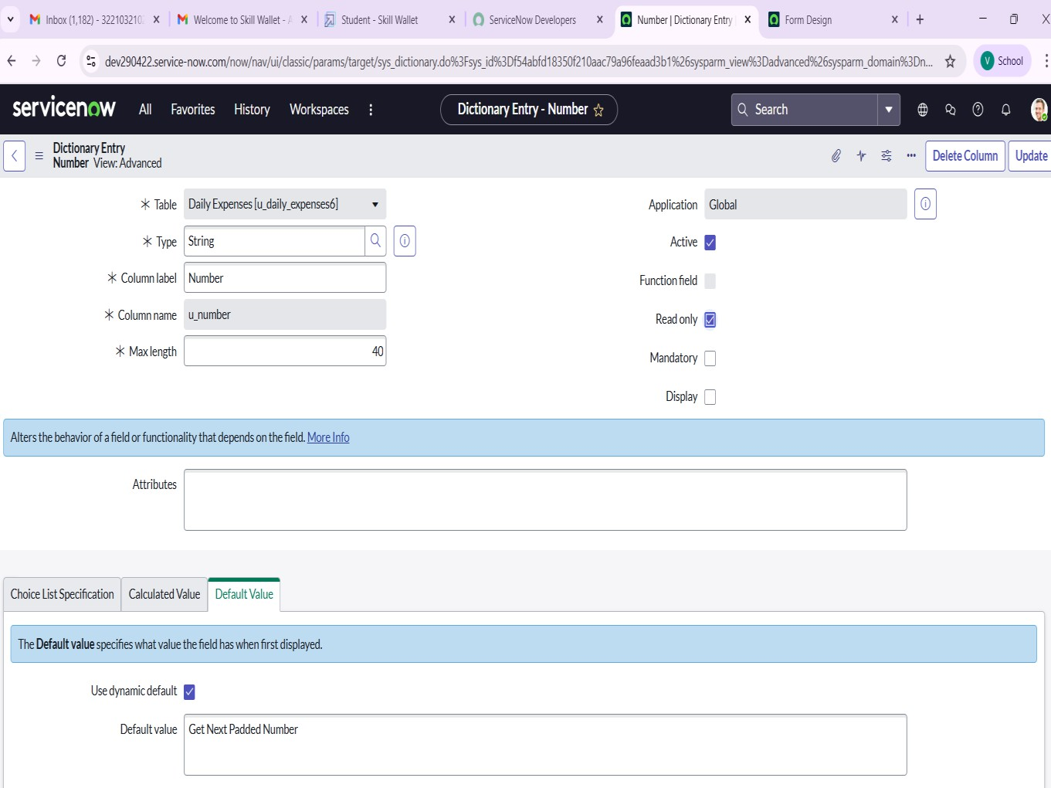

**Configure the Form**

# 

# 

# Creation of Relationship

# Configuring Related List on Family Expenses

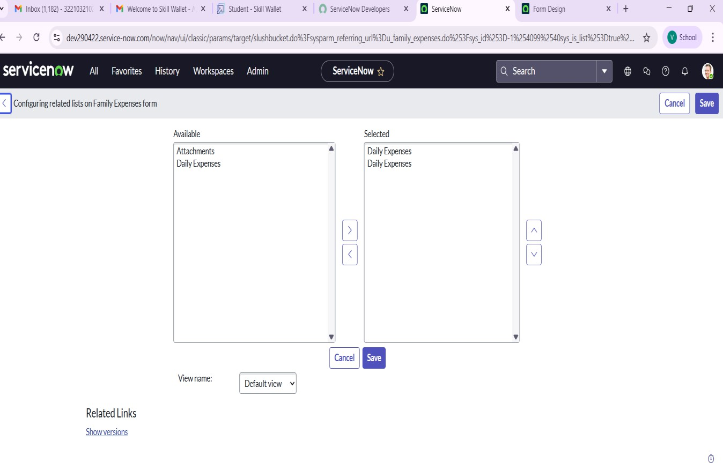

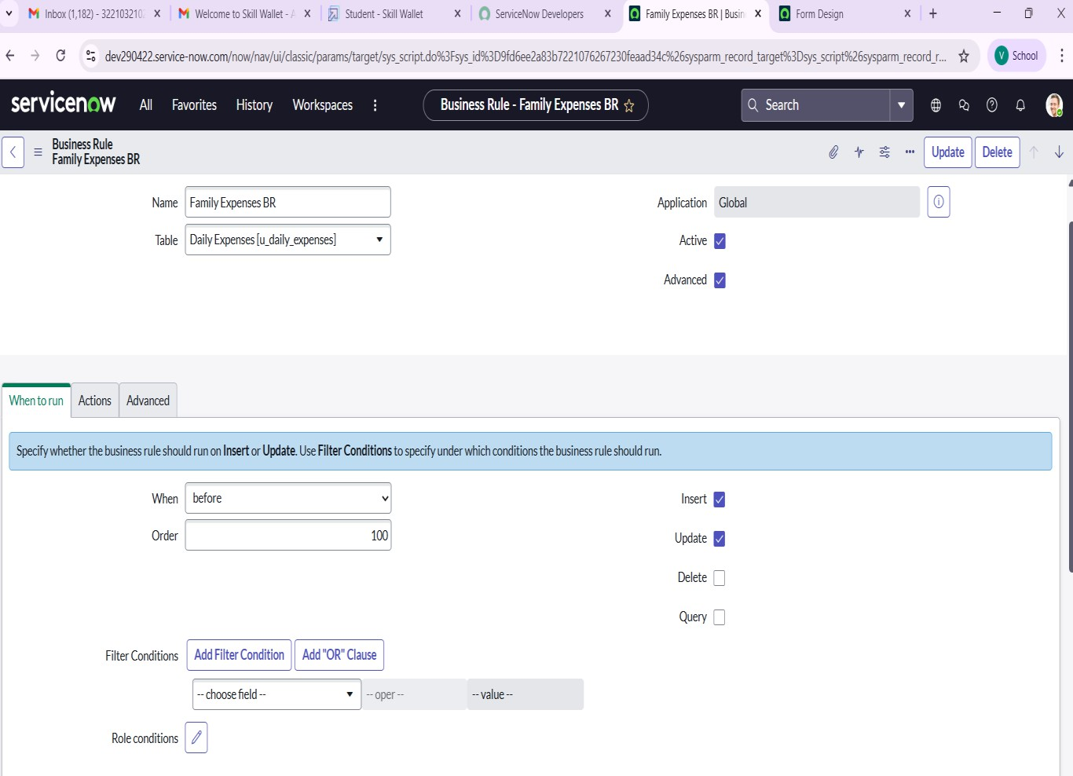**Business Rules on Family Expenses BR**

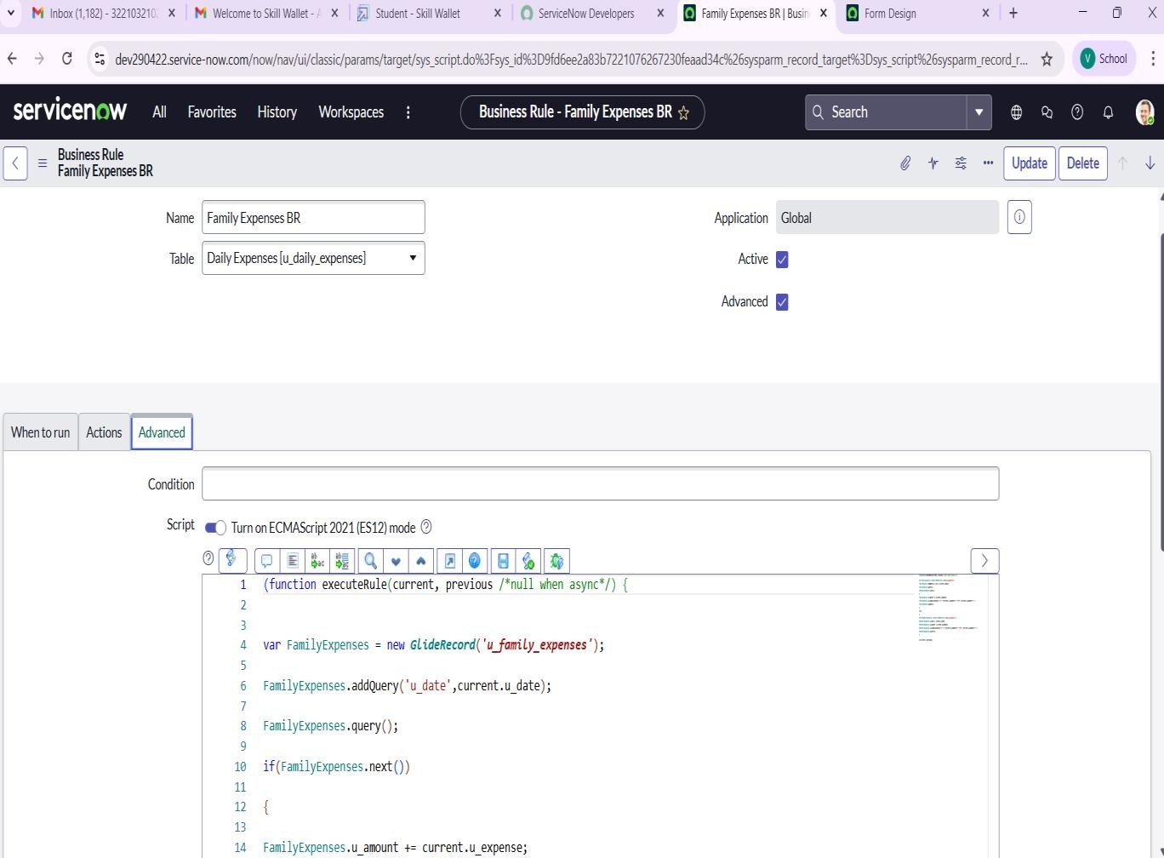

# Conclusion

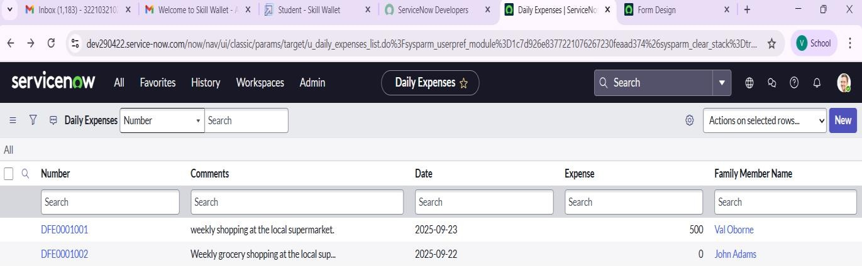

Daily Expenses

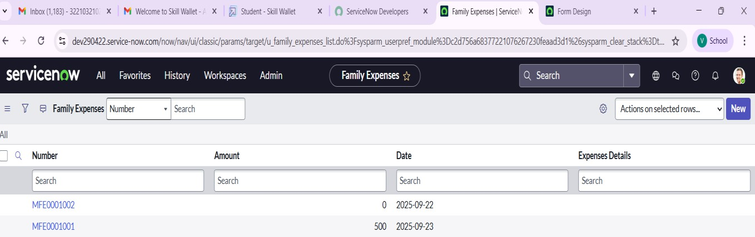

Family Expenses.